LAB Logbook

Lab 1

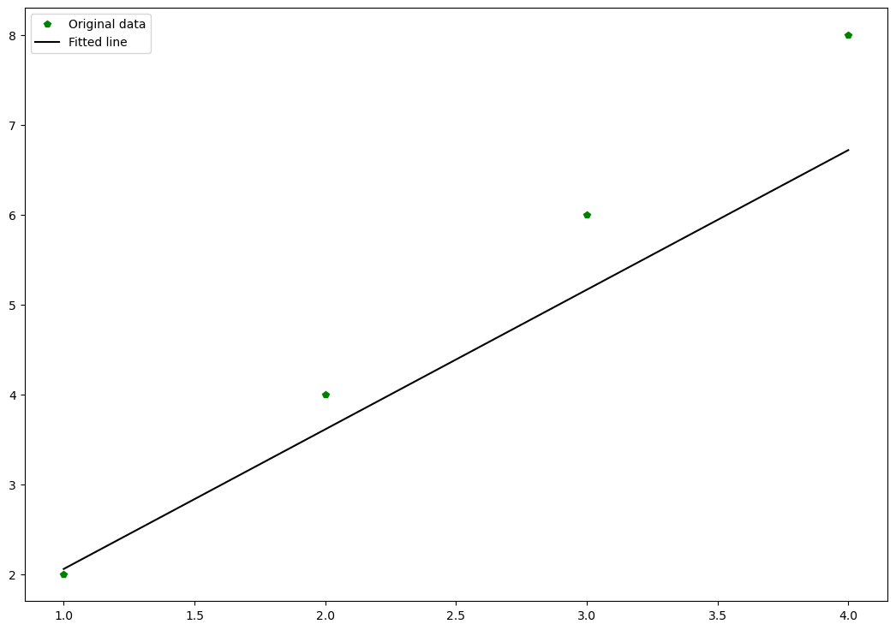

Lab 2

Accuracy: “0.940”

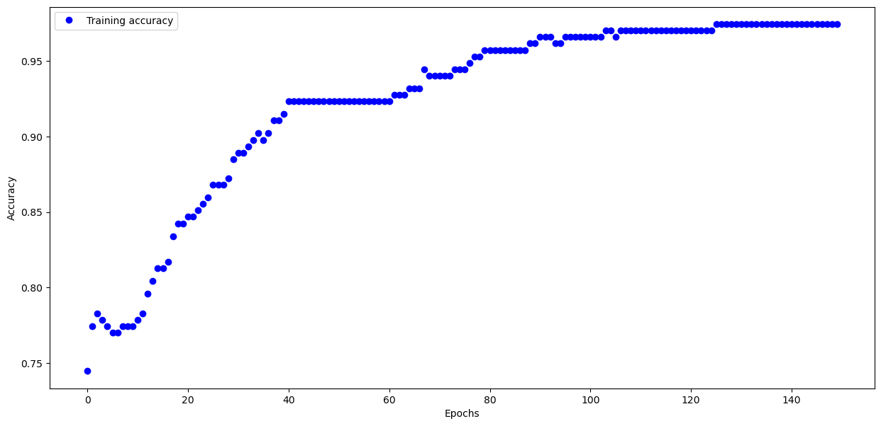

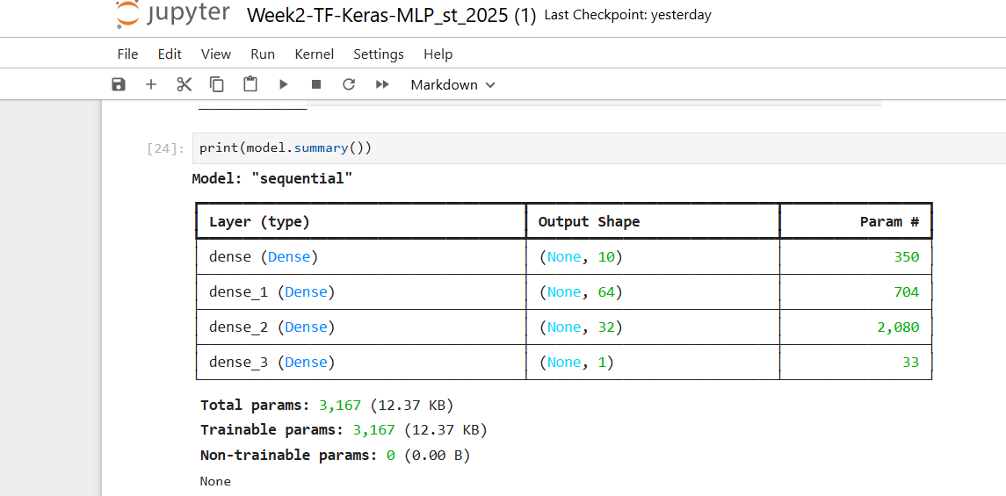

Lab 3

Test accuracy: 0.8341000080108643

Model summary:

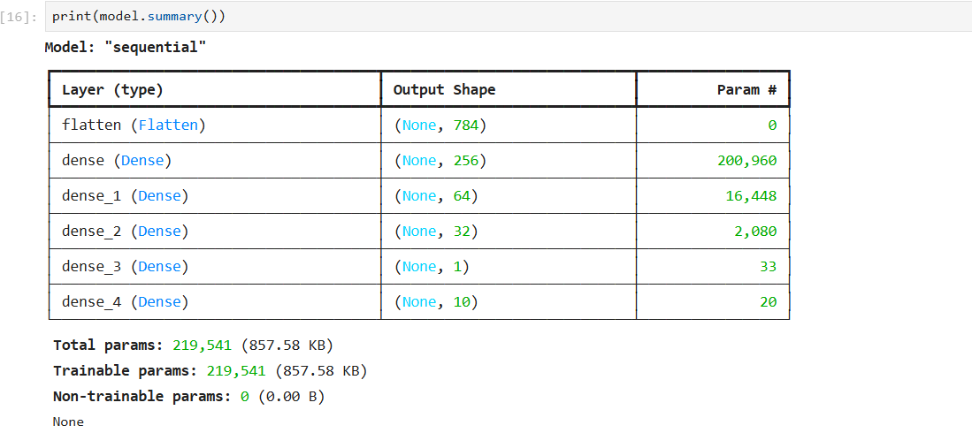

Lab 4

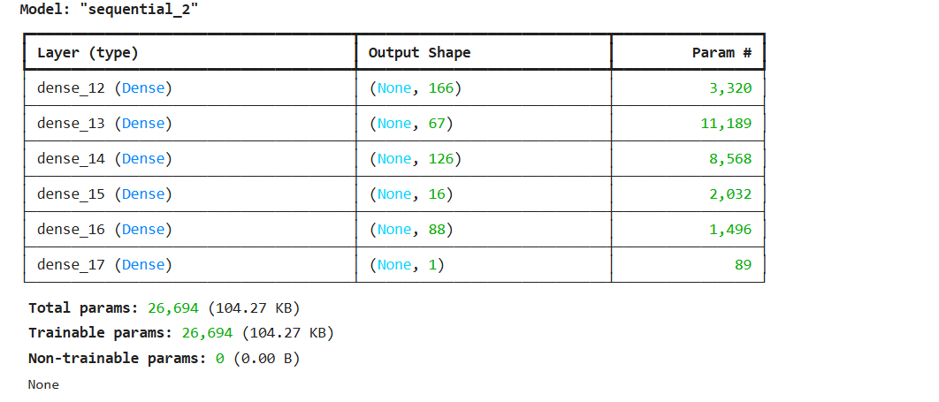

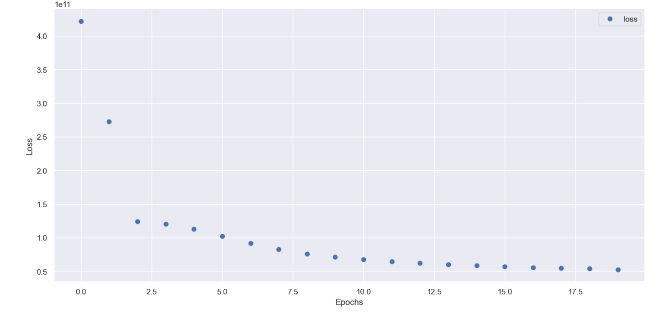

absolute prediction error = 76580.0 $

relative prediction error = 34.511041009463725 %

Lab 5

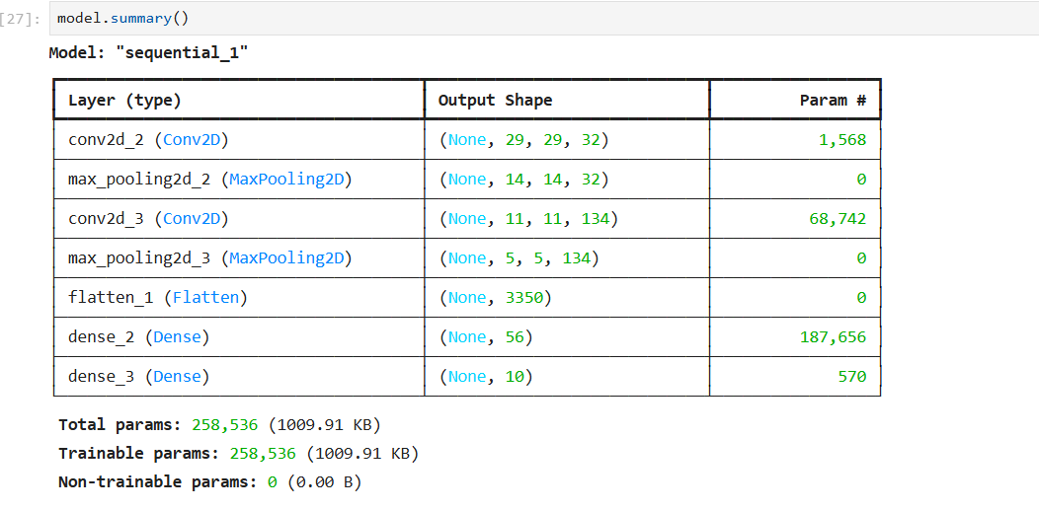

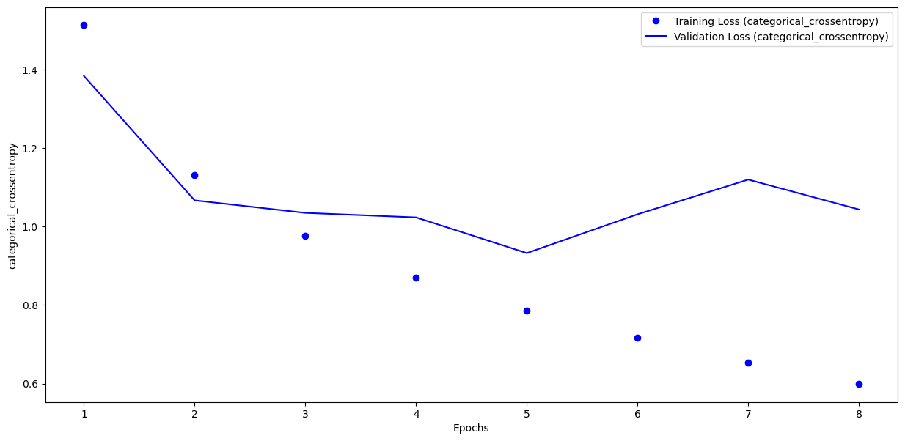

Optimal number of epochs :08

Lab 6

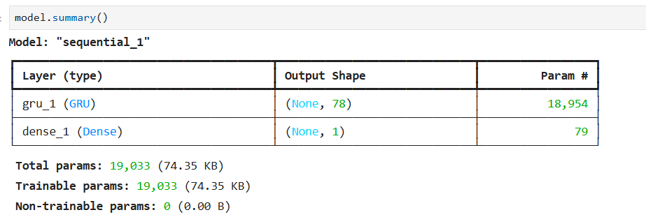

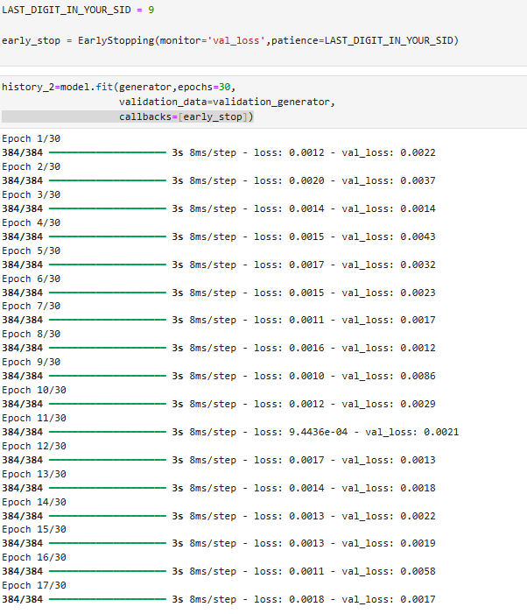

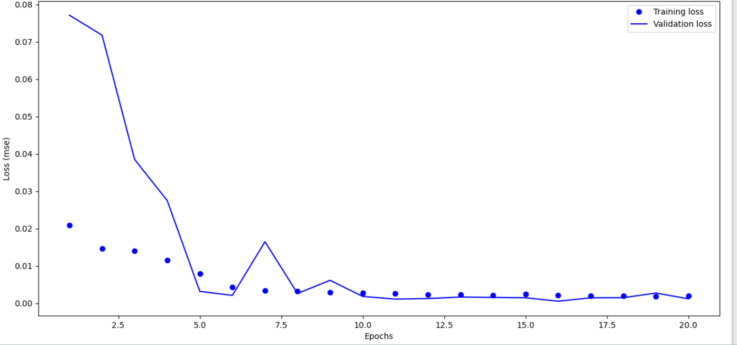

Low val_loss founded at epoch 8/30 that is 0.0012

Lab 7

Lab 8

Lab 9

Lab 10

Lab 11

Lab 12